TASK 2

Design a simple calculator with basic arithmetic operations.

Prompt the user to input two numbers and an operation choice.

Perform the calculation and display the result.

CODE:

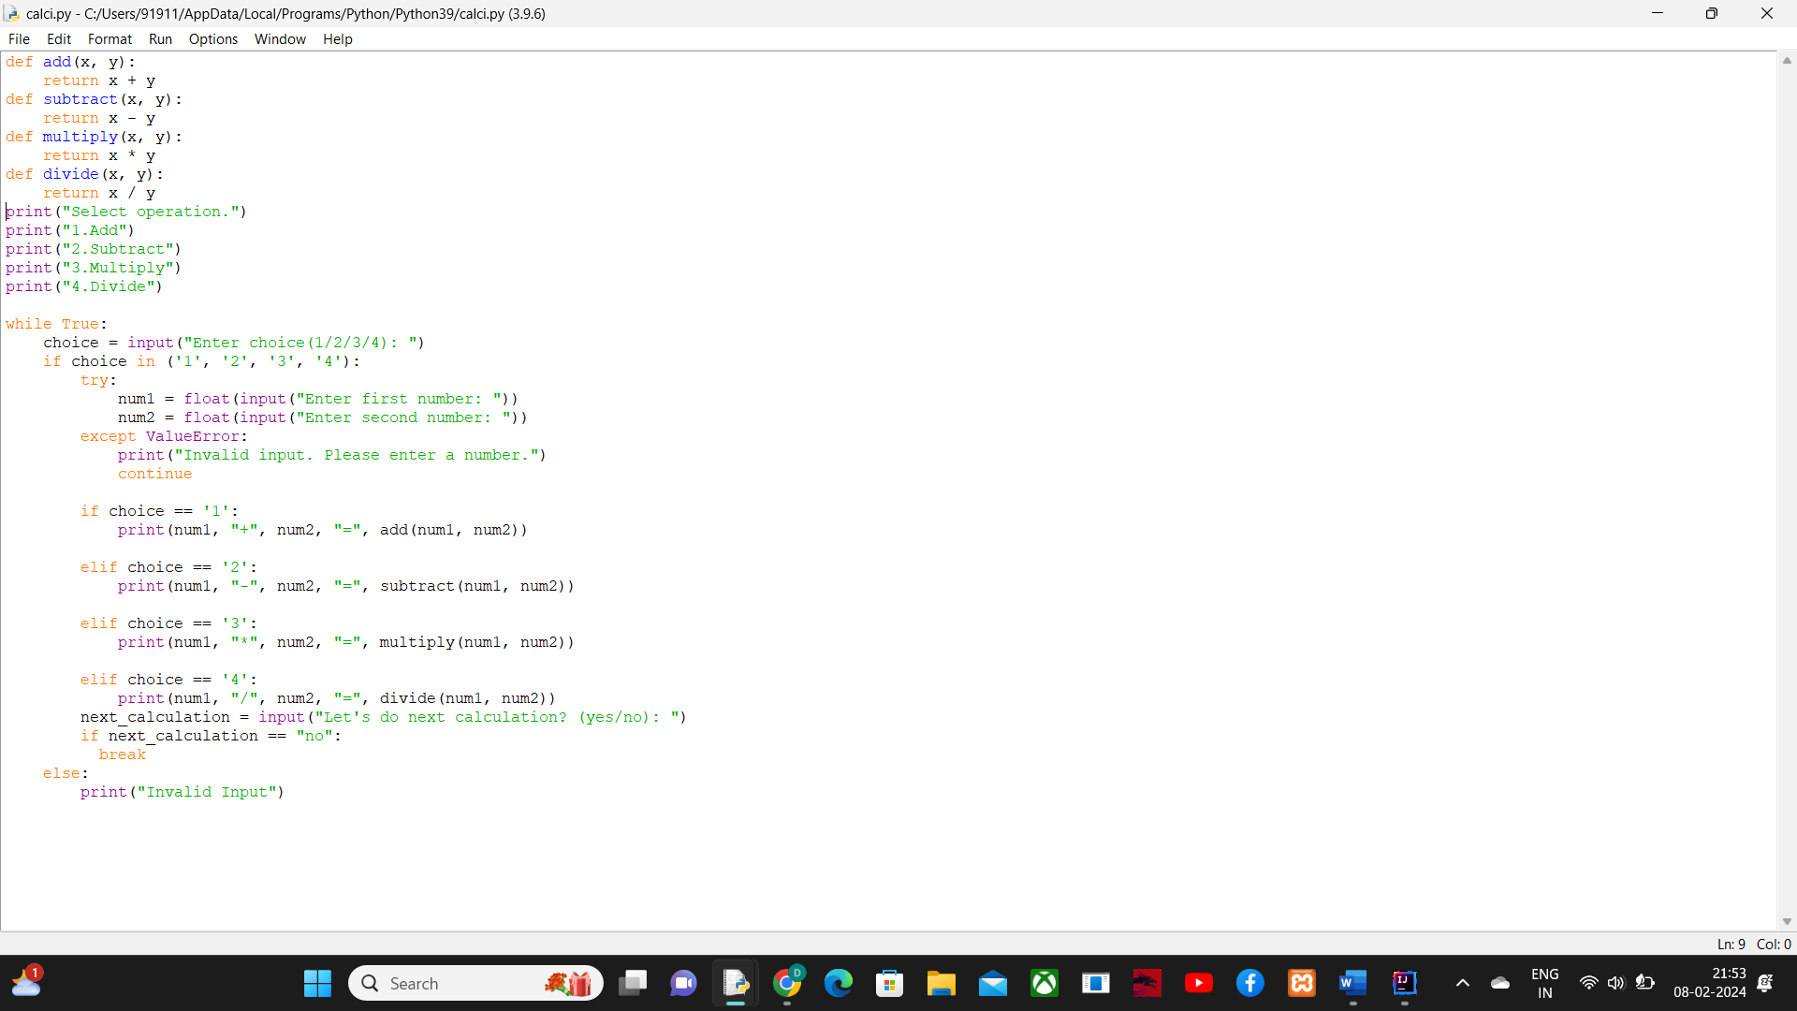

OUTPUT:

